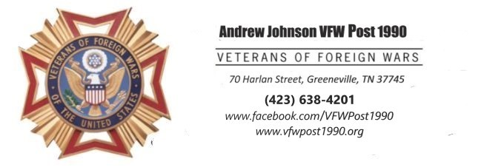
Memorial Hall
For Rent

For Parties, Meetings, Weddings, Wedding
Reception, Celebration of Life,
Family Reunion, Other Purposes

4000 Square Feet furnished as requested
Maximum occupants- 125
Rentals for 3 hours with additional 1 hour for clean-up.
Cost
VFW Members - $100
Veterans- $200
Non-Veterans- $300
For Weekend or weekly rate, call (423) 638-4201

VFW Post 1990 does not sell or serve Alcohol

